Bash Scripting Video Executions - Day 1
Launched a new Instance 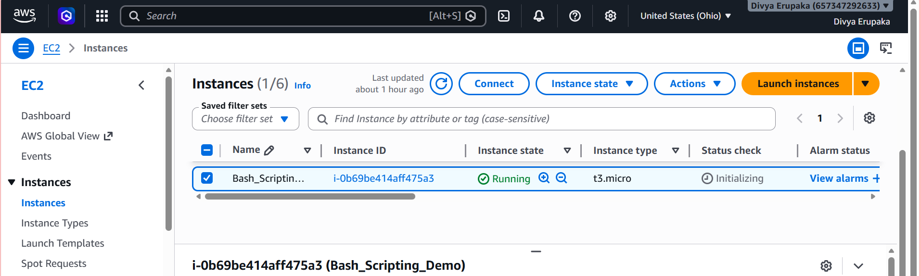
Logged into new instance with ssh -I command and moved into root user with sudo -i
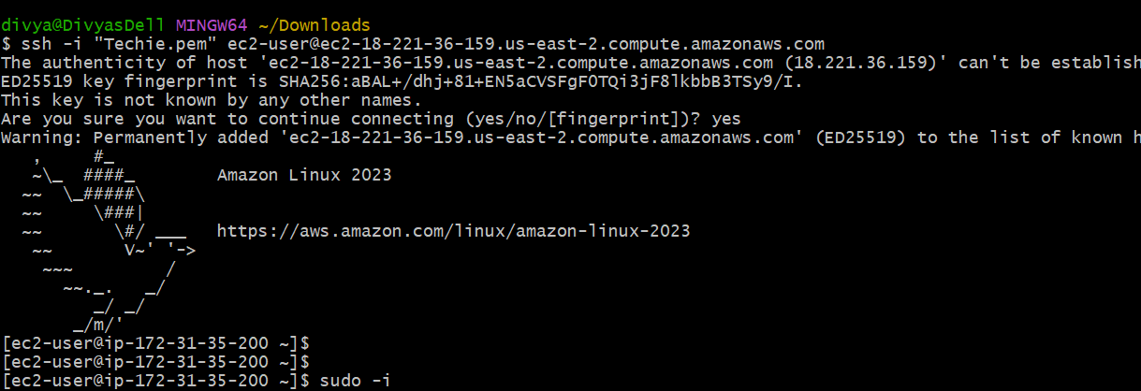
Example of bash scripting to run commands automatically with ./file.bash instead of manually running each commad.
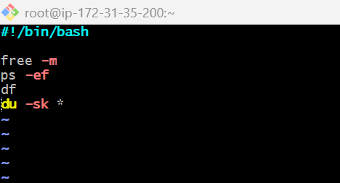
Create a file with extension .bash and start the fil using (#! – shebang) continue with shell /bin/bash
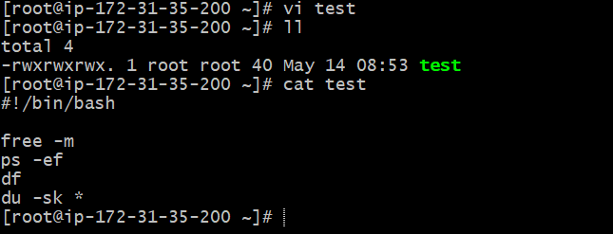
Provide execution permissions to owner and execute the command we need to use ./file.bash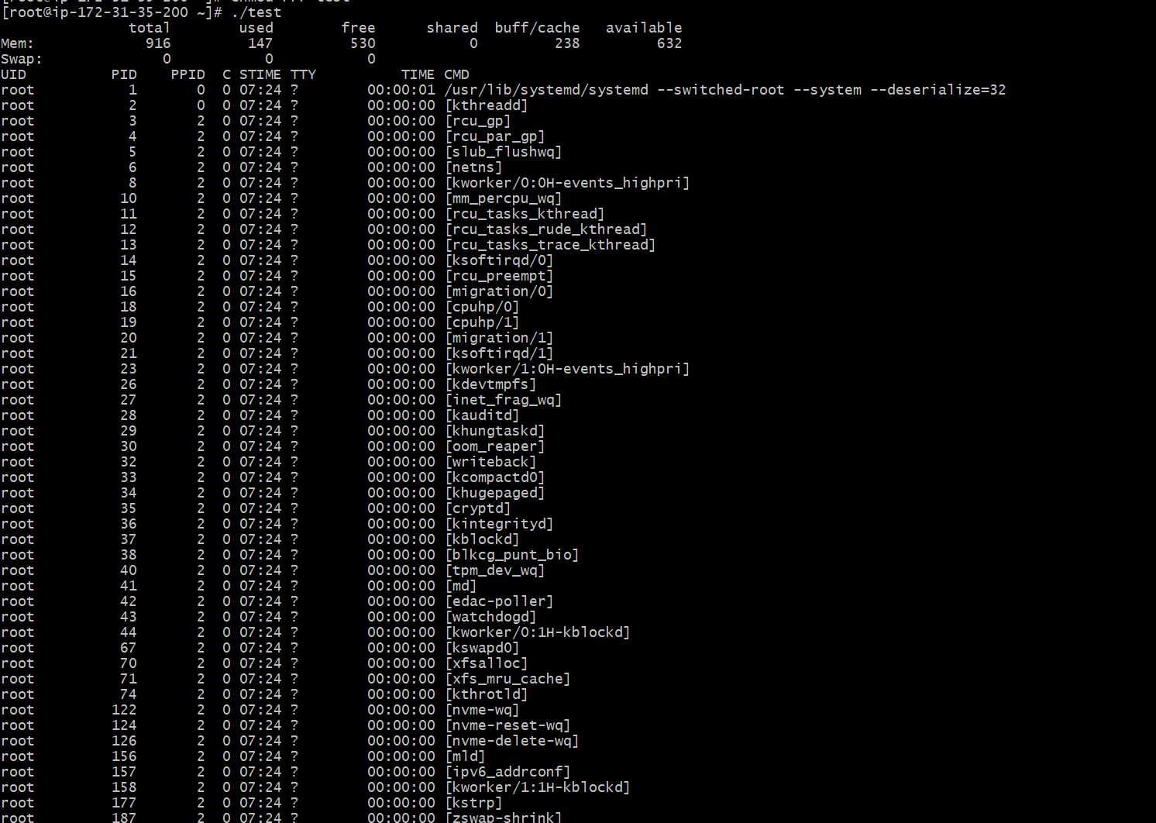
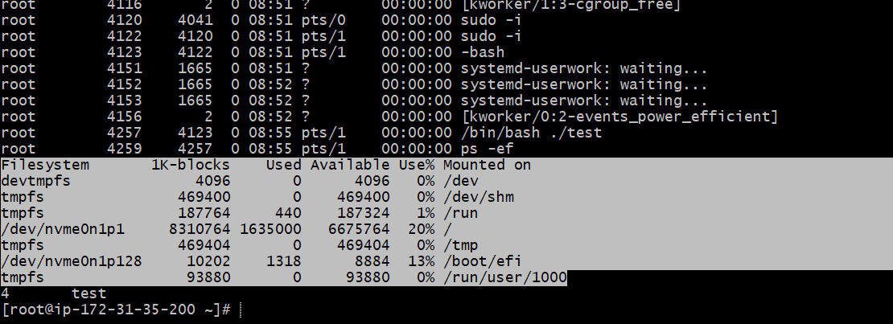
Finding Current Shell and Available Shells
Outcome:- Successfully identified current shell, available shells, and user assigned shell in Linux.
Objective:- To learn how to identify shells configured in Linux systems.
Prerequisites:- Linux terminal access
Step-by-Step Implementation
Step 1: Check Current Shell
Command Used echo $0
Expected Output -bash
Explanation
$0 displays currently active shell.
Step 2: Check Available Shells
Command Used cat /etc/shells
Explanation Displays all installed shells available in the system.
Step 3: Check User Assigned Shell
Command Used cat /etc/passwd
Explanation Displays all users and their assigned shells.
Validation Steps
Validation | Expected Result
echo $0 | Shows active shell
cat /etc/shells | Displays installed shells
cat /etc/passwd | Displays user shell assignment
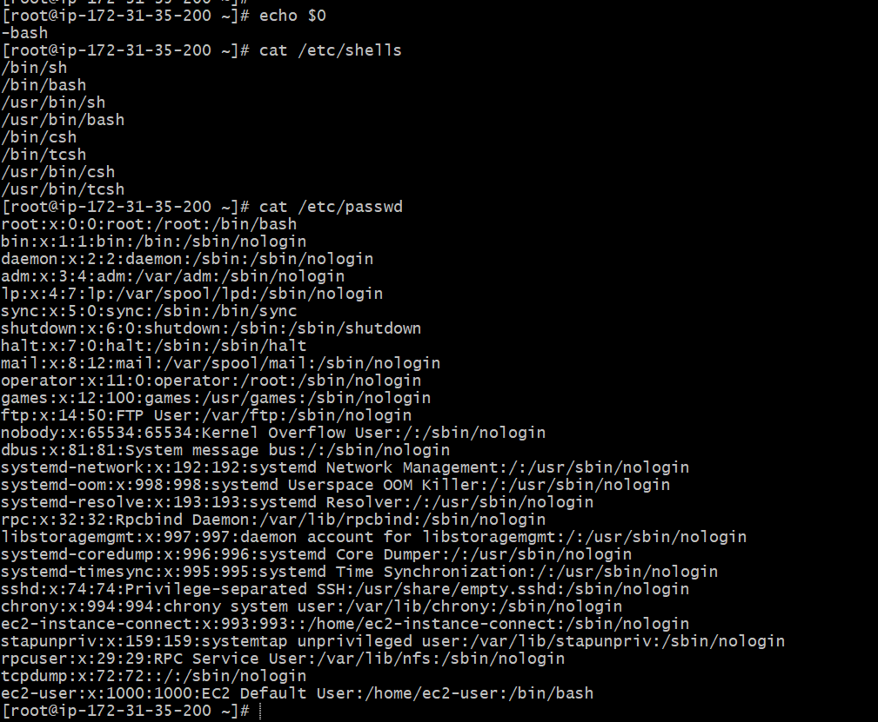
To switch to different shell we can just give sh and check echo $0 and to come out of shell run exit command.
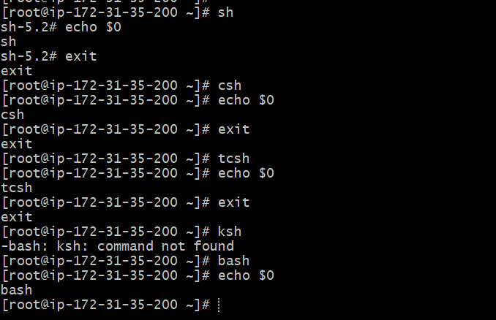
Task 1: Create a Basic Shell Script – Hello World
Outcome:- Successfully created and executed a basic shell script that prints “Hello World” as output.
Objective:- The objective of this task is to understand the basic structure of a shell script and learn how to execute commands using Bash scripting.
Prerequisites:- Before starting this task, the following requirements were needed:
- Linux system access
- Bash shell availability
- Basic knowledge of terminal commands
- Text editor such as vi
Step-by-Step Implementation:-
In this task, a basic shell script was created using the Bash shell. First, a new file named helloworld.bash was created using a text editor. Inside the script, the shebang line #!/bin/bash was added to define the shell interpreter. Then the echo command was used to print the message “Hello World”.
Script Used
#!/bin/bash
echo "Hello World"
After saving the file, executable permissions were assigned using the chmod command.
Permission Command
chmod 755 hello.sh
The script was then executed using the following command:
./helloworld.bash
The output displayed the message “Hello World!” successfully.
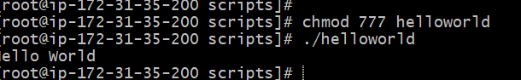
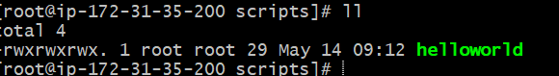
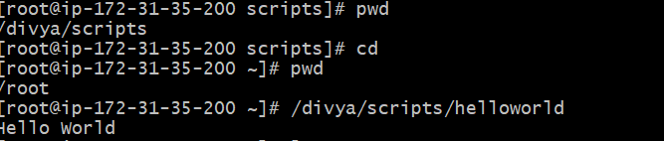
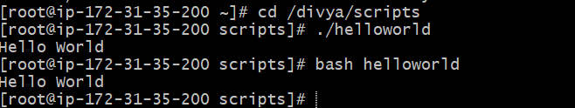
Validation Steps:- The script execution was validated by checking whether the output displayed the expected “Hello World!” message without any errors.
Explanation
This task demonstrated the basic syntax of shell scripting. The echo command is used to print output on the terminal, while the shebang (#!/bin/bash) specifies that the script should be executed using the Bash interpreter.
Shell scripting is commonly used to automate repetitive administrative and operational tasks in Linux systems.
Real-Time Use Case
In real-time environments, basic shell scripts are used to automate startup tasks, health checks, log generation, and deployment activities.
Common Errors and Troubleshooting
Error | Cause | Resolution
Permission denied | Script not executable | Use chmod 755 helloworld.bash
Bad interpreter | Incorrect shebang | Use #!/bin/bash
Command not found | Typing mistake | Verify command syntax
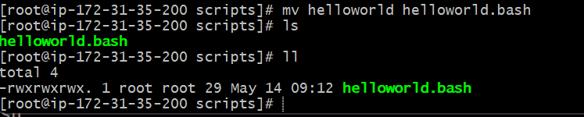
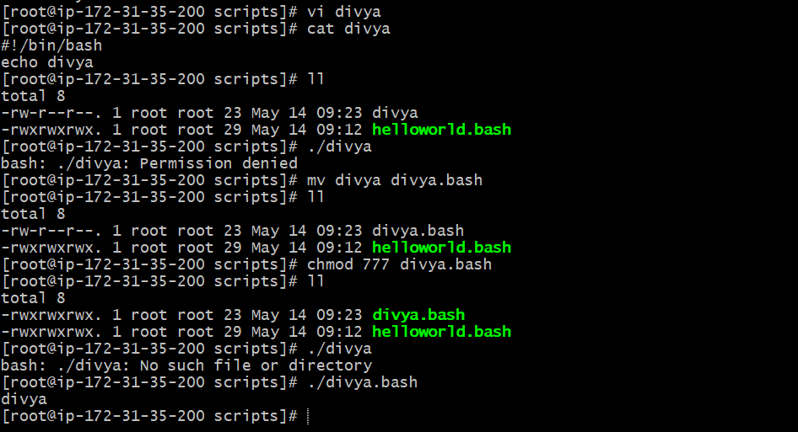
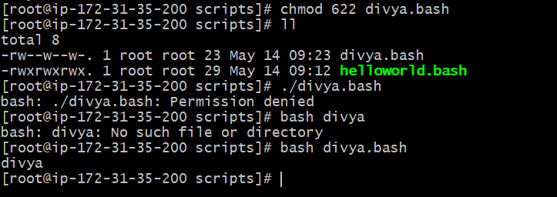
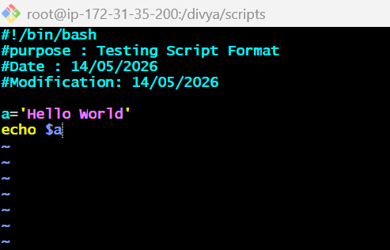
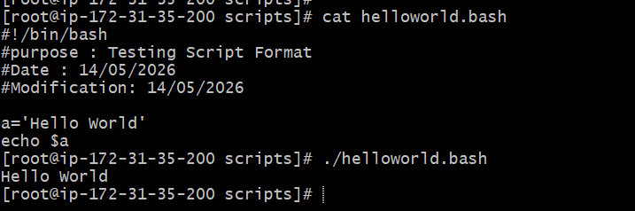
2. Task 2: Create and Execute a Basic System Information Script
Outcome:- Successfully created and executed a shell script that displays system information and creates files.
Objective:- The objective of this task is to understand how multiple Linux commands can be combined inside a shell script to automate system-related operations.
Step-by-Step Implementation:-
In this task, a shell script was created to execute multiple Linux commands sequentially. A file named basic.sh was created and edited using a text editor. The Bash interpreter line was added at the top of the script.
The script included commands such as:
- pwd to display the present working directory
- ls to list files and directories
- whoami to display current logged-in user
- date to show current date and time
- cal to display calendar
- touch to create empty files
Script Used
#!/bin/bash
pwd
ls
whoami
date
cal
touch a b c
After saving the script, execute permissions were provided using the chmod command.
chmod 755 basic.sh
The script was executed using:
./basic.sh
The output displayed system information and created three empty files named a, b, and c.
Validation Steps:-
Validation was performed by:
- Checking command outputs
- Verifying file creation using ls
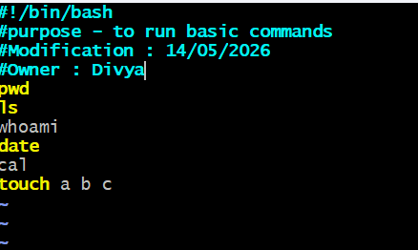
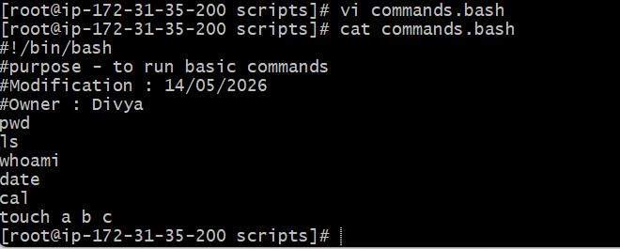
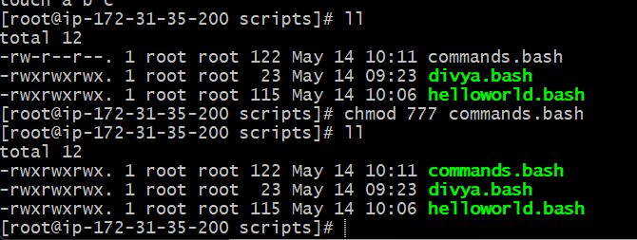
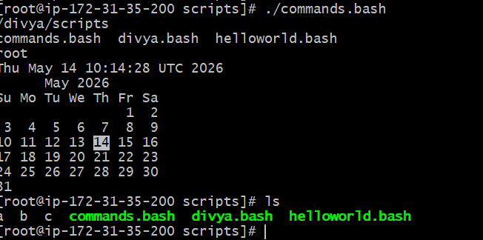
Task 3: Perform Basic Administration Tasks Using Linux Commands
Outcome:- Successfully executed Linux administration commands to monitor system performance and resource utilization.
Objective:- The objective of this task is to learn commonly used Linux administration commands for monitoring CPU, memory, disk usage, uptime, and system performance.
Step-by-Step Implementation:-
In this task, multiple Linux administration commands were executed individually from the terminal to monitor server resources and system health.
The following commands were used:
Commands Used
top
df -h
free -m
uptime
iostat
The top command continuously monitors running processes and resource utilization. Since it continuously refreshes output and appears stuck, the following command was used to limit the output:
top | head -10
The df -h command displayed disk usage in human-readable format, while free -m displayed memory usage in megabytes.
The uptime command displayed server running time and load averages. The iostat command was used to monitor CPU and disk statistics.
Validation Steps:-
- Validation was performed by confirming:
- Resource statistics displayed correctly
- Disk and memory usage information appeared
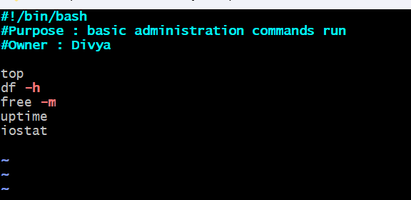
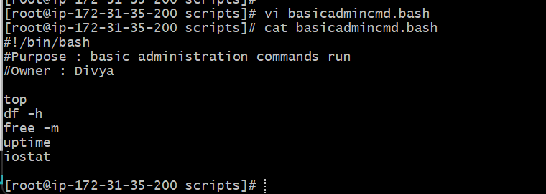
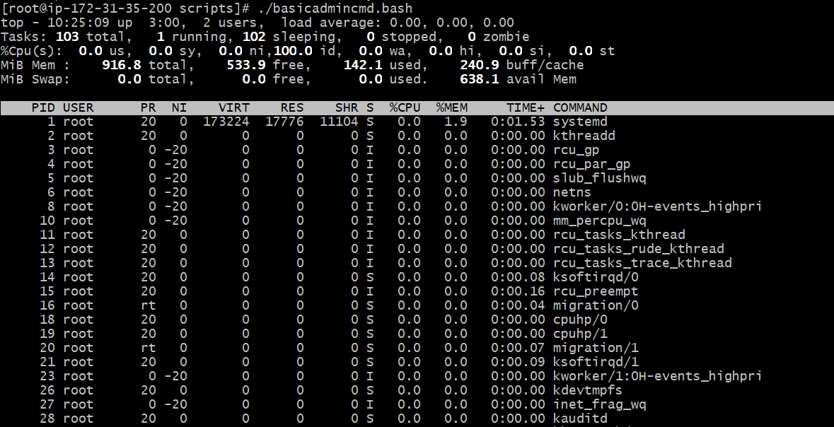
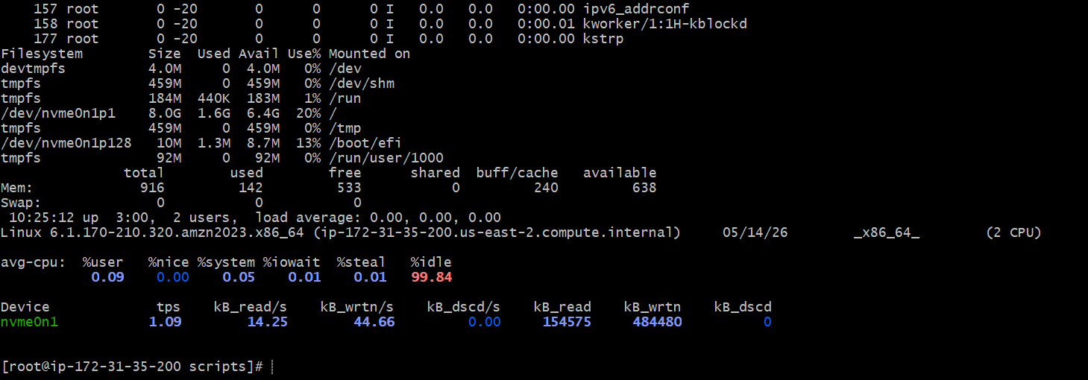
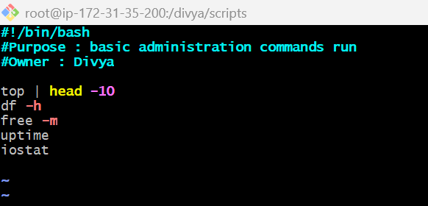
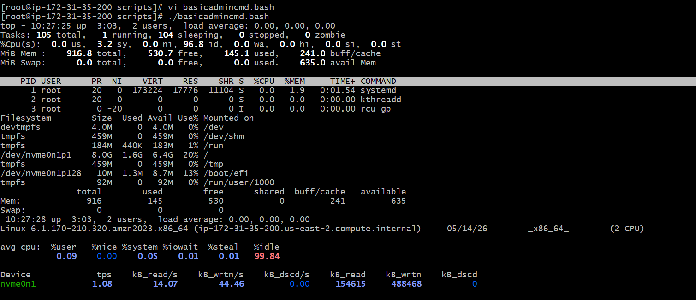
Task 4: Defining Variables in Bash Script
Outcome:- Successfully created and executed a shell script using variables.
Objective:- The objective of this task is to understand how variables are declared and used in Bash scripting.
Step-by-Step Implementation:-
In this task, variables were defined inside a shell script to store Linux commands. A script file was created and variables were assigned values such as pwd, ls, whoami, date, and cal.
The variables were later executed using the $ symbol.
The script was saved and executed after assigning execute permissions.
Validation Steps:- Validation was performed by checking whether all commands stored in variables executed successfully.
Explanation
Variables are used to store values temporarily inside scripts. In Bash scripting, variables can store strings, commands, numbers, or user input. The $ symbol is used to access variable values.
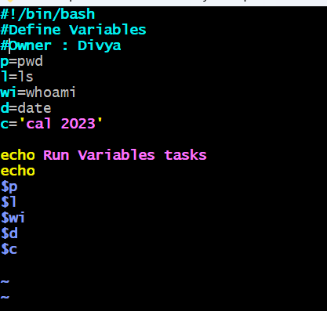
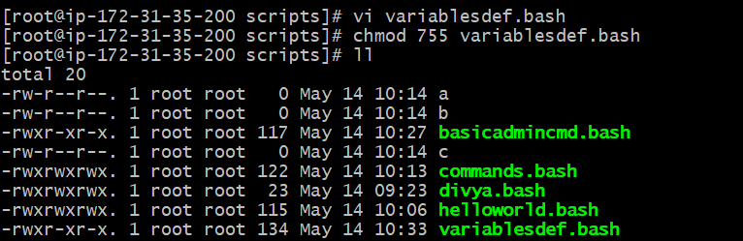
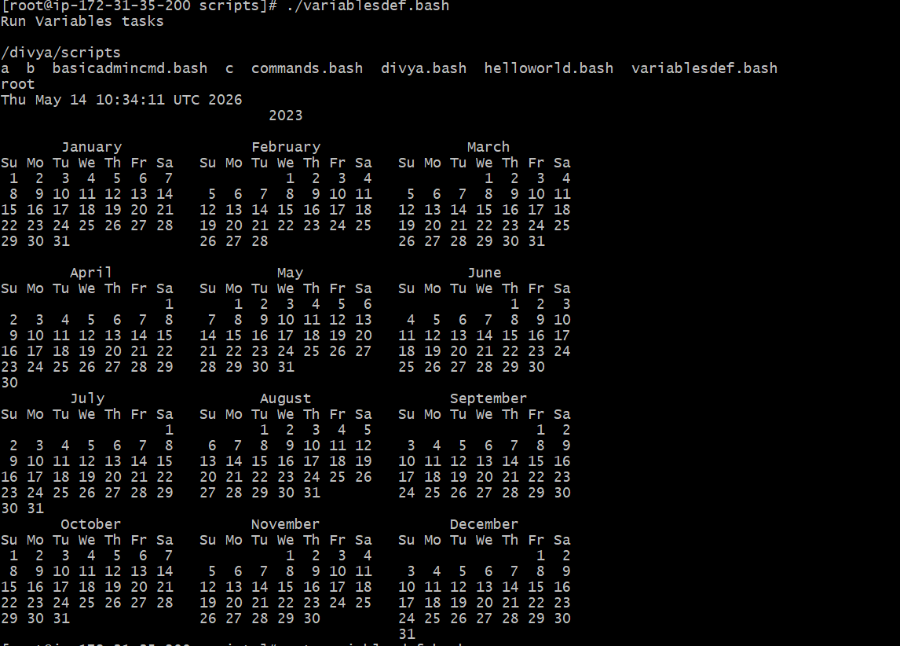
Task 5: Input and Output Shell Script Using read and echo
Outcome:- Successfully created interactive shell scripts that accept user input and display dynamic output.
Objective:- The objective of this task is to understand how to interact with users in shell scripting using read and echo commands.
Step-by-Step Implementation:-
In this task, interactive shell scripts were created using read and echo. The echo command was used to print output on the terminal, while the read command accepted user input dynamically.
The first script asked the user to enter their name and displayed a greeting message.
Both scripts were executed successfully after assigning execute permissions.
Validation Steps:- Validation was completed by:
Entering user input successfully
Verifying dynamic greeting output
Checking hostname display
Explanation
The read command pauses script execution and waits for user input. The echo command displays output messages. Backticks ( ` ` ) are used for command substitution, meaning command output is stored inside a variable.
Common Errors and Troubleshooting
Error | Cause | Resolution
Input not accepted | Missing read command | Add read statement
Variable empty | Incorrect variable usage | Use $variable
Hostname not displaying | Command substitution issue | Use backticks correctly
Script 1 Screenshots
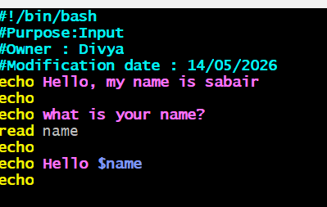
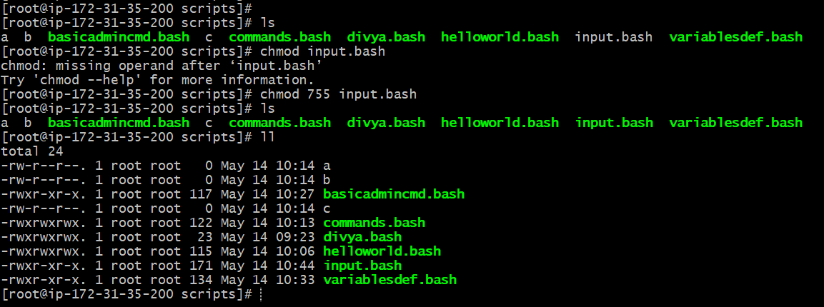
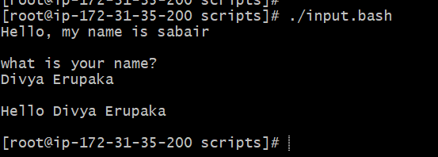
Script 2 Screenshoots
